Reinforcement Learning Based Recommendation System: An In-Depth Review of Models and their Limitations

*Dhaval Mehta*  
Computer Engineering Department*

*MPSTME, NMIMS University  
Mumbai - 400056, India  
dhavalmehta5604@gmail.com*

*Shranth Naik  
Computer Engineering Department*

*MPSTME, NMIMS University  
Mumbai - 400056, India  
@gmail.com* *Nipun Dahiya   
Computer Engineering Department*

*MPSTME, NMIMS University  
Mumbai - 400056, India  
nipundahiya2004@gmail.com*

*Pashin Kasad  
Computer Engineering Department*

*MPSTME, NMIMS University  
Mumbai - 400056, India  
 @gmail.com*

*Abstract*— Fake news proliferation on digital platforms has emerged as a critical global challenge, undermining information integrity and public trust. This study presents a comprehensive comparative analysis of natural language processing (NLP) and deep learning (DL) models for automated fake news detection. Building upon extensive literature spanning traditional machine learning, recurrent neural networks (LSTM, Bi-LSTM), and transformer-based architectures (BERT, RoBERTa), this research systematically evaluates performance, dataset diversity, and model robustness. Experiments employing hybrid architectures—such as BERT-CNN, RoBERTa-BiLSTM, and GRU-GloVe—demonstrate significant improvements in contextual understanding and feature extraction, achieving accuracies up to 99%. Dataset frequency analysis further reveals benchmark trends across sources like Kaggle, Twitter, and fact-checking repositories. The findings underscore the superiority of transformer-based and hybrid architectures in achieving both precision and generalizability, while also identifying key research gaps in multilingual adaptability, explainability, and real-time deployment. This comparative framework provides an integrated perspective on current advancements and future directions for developing scalable, transparent, and reliable fake news detection systems.

Keywords— Recommendation Systems, DDPG, MAB, MARL, Algorithms, Models, PPO, T3D.

# Introduction

The exponential growth of social media and online journalism has transformed how information is disseminated and consumed. However, this digital democratization has also amplified the spread of misinformation and fake news—content deliberately designed to mislead, manipulate, or polarize audiences. The societal implications are profound, influencing public opinion, political stability, and even public health during crises such as the COVID-19 pandemic. As manual verification becomes infeasible at scale, automated fake news detection has become a central research priority in natural language processing (NLP) and artificial intelligence (AI).

Early efforts in this field relied on traditional machine learning algorithms utilizing handcrafted linguistic and lexical features. While effective to an extent, these approaches struggled with semantic ambiguity, contextual variation, and domain transferability. The emergence of deep learning (DL) revolutionized this landscape by enabling models to learn hierarchical and contextual representations directly from text. Recurrent architectures such as Long Short-Term Memory (LSTM) and Gated Recurrent Units (GRU) improved temporal understanding, while Convolutional Neural Networks (CNN) captured local dependencies and n-gram features. The introduction of transformer models—particularly BERT, RoBERTa, and their variants—marked a paradigm shift, offering superior contextual comprehension through attention mechanisms and large-scale pre-training.

Despite remarkable progress, challenges remain. Fake news detection systems often face limitations related to dataset imbalance, multilingual generalization, and explainability. Moreover, the increasing prevalence of multimodal misinformation, combining text, imagery, and metadata, necessitates more holistic solutions. Hybrid and ensemble architectures have recently emerged as promising strategies, integrating linguistic, contextual, and social features for improved robustness.

This study contributes to the ongoing discourse by conducting a detailed comparative analysis of NLP and DL architectures for fake news detection. It examines their evolution, performance benchmarks, and dataset utilization patterns while evaluating hybrid frameworks that combine transformer models with recurrent and convolutional components. Beyond benchmarking, the paper identifies critical gaps and proposes directions toward developing scalable, explainable, and multilingual detection systems capable of operating in real-time environments. Through this synthesis, the work aims to advance the understanding of how modern NLP and DL methodologies can collectively fortify the digital information ecosystem against misinformation.

# Literature Review

This literature review surveys the evolution of fake news detection, tracing the field's progression from traditional machine learning (ML) to advanced deep learning (DL) models. It examines key architectures, including recurrent networks (LSTM/Bi-LSTM), transformers (BERT/RoBERTa) , and hybrid approaches. The review also explores state-of-the-art methods integrating multi-modal data and social context using Graph Neural Networks (GNNs). It concludes by summarizing common challenges, such as the need for multilingual datasets , real-time systems, and model explainability.

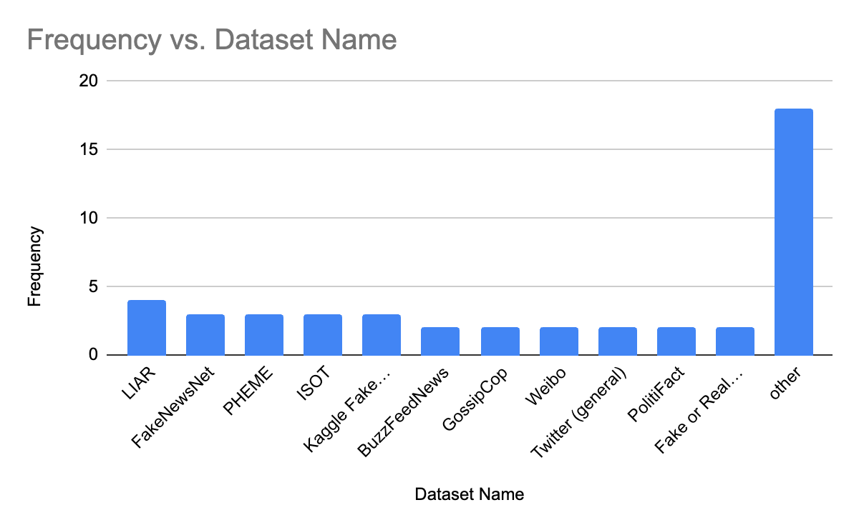

The following bar chart illustrates the frequency of unique datasets used across the surveyed research papers. This visualization highlights the most commonly employed datasets such as LIAR, FakeNewsNet, and ISOT, offering insights into prevailing trends and benchmark preferences within the fake news detection domain. It was added to emphasize dataset usage patterns and identify which sources are most influential or widely adopted in existing research.

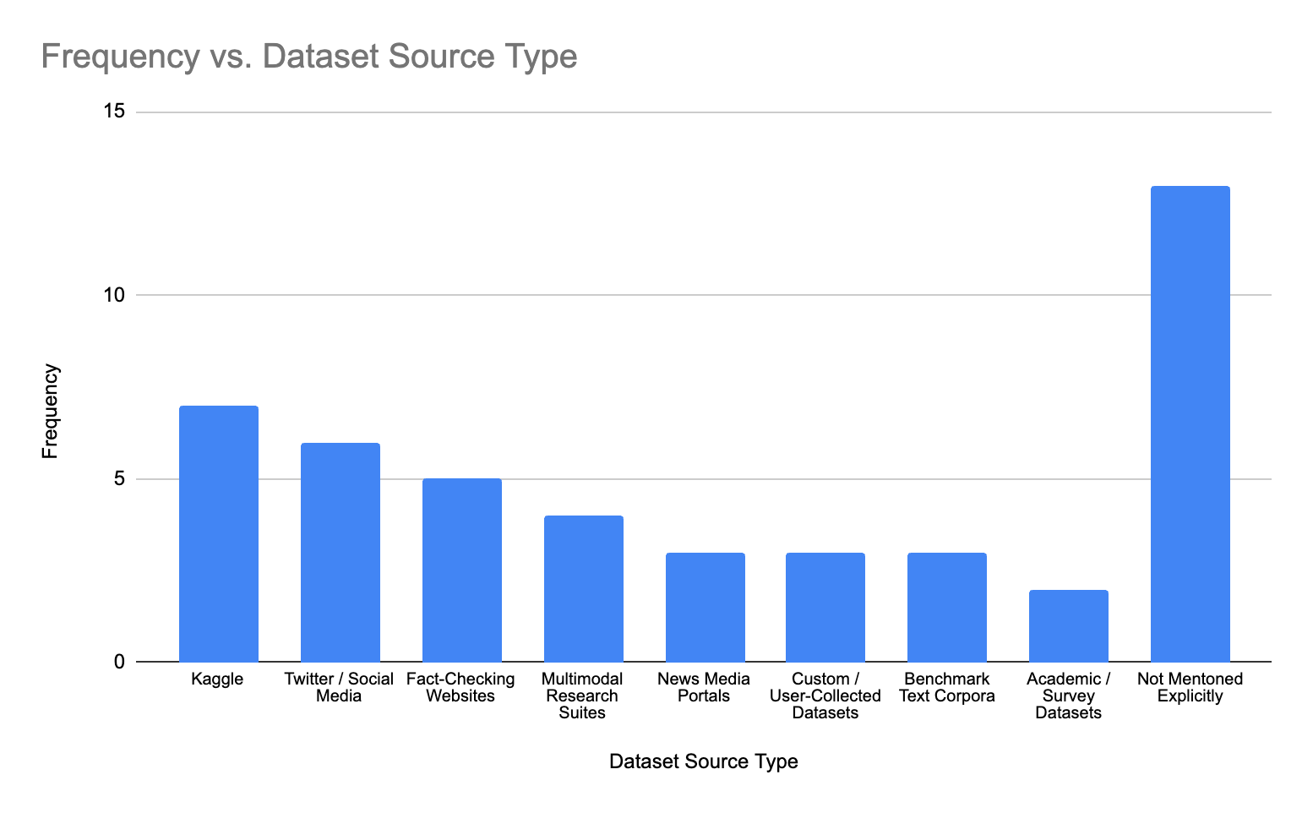

The following bar chart illustrates the frequency of unique datasets sources used across the surveyed research papers. This visualization highlights the most commonly employed datasets sources such as Kaggle, Twitter/Social Media, and Fact-Checking Website, offering insights into prevailing trends and benchmark preferences within the fake news detection domain. It was added to emphasize source usage patterns and identify which sources are most influential or widely adopted in existing research

[1] presents a comparative study of four deep learning models for real-time fake news detection. ALBERT achieved the highest accuracy (100%) across all evaluated datasets.

A combination of CNN and RNN also yielded strong results, especially for detecting informal patterns and slang. The study used multiple datasets, focusing on binary classification between real and fake news. Future work emphasizes building a scalable, multilingual model using more diverse and expansive datasets.

[2] Proposed a hybrid LSTM + Word2Vec system for fake news detection Achieves up to 94% accuracy on diverse datasets, proving model compatibility Identifies key factors like data diversity, vector size, and training cycles as critical to accuracy. Overfitting and poor generalization noted when trained on topic-narrow datasets. Recommends using larger, more diverse datasets and improved training hardware for future systems

[3] evaluates and compares traditional ML algorithms for fake news detection using TF-IDF vectorization.Passive Aggressive Classifier achieved the highest accuracy (96.19%), outperforming SVM, Naïve Bayes, Logistic Regression, and Random Forest.

The dataset used is from Kaggle, and standard preprocessing steps (stop word removal, stemming) were applied. The paper identifies the need for testing on multilingual, real-world, and larger datasets. Recommends future work using deep learning and expanding to real-time applications for practical deployment.

[4] Tackles fake news detection using LSTM and Bi-LSTM models with enhanced feature extraction using one-hot encoding. A well-structured preprocessing pipeline is implemented including tokenization, stop word removal, and lemmatization. Political news datasets with labels from PolitiFact are used, achieving ~98% accuracy with Bi-LSTM. Comprehensive evaluation metrics (accuracy, precision, recall, F1-score) confirm the superiority of Bi-LSTM.

Future work suggests including multimodal inputs and applying the method to other domains like COVID-19 or education.

[5] Proposes a new method to stabilize propagation paths in social media using both structure and time. Introduces a GRU-based deep learning model incorporating user features for fake news detection. Evaluated using the Twitter18 dataset and compared with other deep models. Achieved highest accuracy of 93.01%, outperforming prior approaches.Demonstrates that propagation timing is a crucial factor in improving model performance.

[6] The paper addresses the problem of detecting fake news by optimizing Hugging Face’s BERT model. A custom linear classifier layer is added on top of BERT for binary classification (REAL/FAKE). Achieved high accuracy (97.71%) with standard metrics confirming model effectiveness. The approach is modular, Python-based, and efficiently uses GPU resources. Future work includes exploring additional architectures and validating across datasets.

[7] The paper proposes and compares BERT, DistilBERT, and RoBERTa for fake news detection. Fake news poses a serious threat to information reliability on digital platforms.

RoBERTa shows the best results due to superior contextual understanding and training methods. Experiments used the ISOT dataset with comprehensive preprocessing and performance metrics. Future research will focus on multilingual, multi-domain, and deep learning integration.

[8] The paper presents an NLP and multi-modal strategy to detect fake news from social media. BERT, SVM, and ensemble models were used and evaluated with high accuracy results. Multi-modal fusion (text + images + metadata) greatly improved performance. Ethical concerns such as fairness and transparency were considered and addressed. The study lays groundwork for real-time and robust fake news detection systems.

[9] The paper proposes a GTN-based fake news detection method leveraging weighted propagation graphs. It introduces a novel time-difference-based edge weighting scheme to improve propagation modeling. The method effectively incorporates user features and textual features into graph learning. Experimental results on FakeNewsNet (Twitter) datasets demonstrate superior performance over GNN-based baselines. The paper does not explicitly outline future work or remaining limitations, but the approach significantly advances propagation-based fake news detection.

[10] The paper introduces a hybrid deep learning architecture for misinformation detection on Twitter.It combines feature-based and text embedding models (GloVe and USE) into a unified framework. Extensive feature engineering at tweet and user levels enhances the model’s capability. Experiments show that hybrid models outperform baseline and state-of-the-art methods. The paper lacks explicit discussion of limitations or detailed future work directions.

[11] Proposes a hybrid neural network combining CNN, LSTM, Transformers, and GCN for misinformation detection. Utilizes text, image, and metadata features for multi-modal detection. Introduces feature fusion with attention and sentiment analysis. Achieves high accuracy (~0.95) with steady precision improvement across training epochs. Provides a scalable framework suitable for real-time misinformation detection but lacks explicit limitations and future work details.

[12] Provides a detailed survey of hybrid deep learning and feature selection techniques for fake news detection. Highlights the effectiveness of CNN-LSTM, attention mechanisms, and transformer models. Emphasizes the importance of multivariate feature selection in improving both performance and efficiency.Demonstrates strong experimental results, with hybrid models outperforming traditional approaches. Identifies key challenges like computational cost, real-time detection, and multilingual support as areas for future work.

[13] Proposes a hybrid BERT Attention-based BiLSTM model for fake text detection. Uses a new combined dataset from multiple sources for evaluation. Achieves 90.24% accuracy, outperforming traditional and baseline deep learning models. Identifies limitations like training cost and lack of multilingual support. Recommends future enhancements for efficiency and language adaptability.

[14] Introduces compact BERT-based models (Tiny and Small) for efficient fake news detection. Proposes a dual-model architecture to process headlines and body text separately. Achieves 90.11% accuracy with BERT-Small, competitive with state-of-the-art. Shows efficiency benefits, making the models suitable for resource-limited environments. Recommends expanding feature sets and dataset diversity for future work.

[15] Paper compares LSTM and BERT for misinformation classification. Uses a Kaggle dataset of ~3000 records with an 80:20 train-test split. BERT achieves 64.88% accuracy, outperforming LSTM’s 60.59%. Identifies BERT as better suited for context-based misinformation detection. Suggests future research on larger datasets and additional metrics.

[16] Provides a comprehensive survey of NLP-based misinformation detection techniques.Reviews a broad set of related tasks, including fact-checking and stance detection.Compiles a list of benchmark datasets used in fake news and rumor detection. Identifies research gaps, especially in dataset availability and evaluation standards.Proposes the need for hybrid, multi-source approaches in future research.

[17] Addresses fake news detection using multiple ML and DL algorithms. Uses Kaggle dataset and standard NLP preprocessing. LSTM outperformed traditional classifiers like SVM and Logistic Regression. Emphasizes the role of text preprocessing. Suggests future work on transformers and larger datasets.

[18] Developed a multi-model NLP-based framework for fake news detection using both word-level and sentence-level features. Employed six deep learning base learners combined via nine ensemble techniques. Achieved state-of-the-art performance using soft weighted voting on multiple benchmark datasets. Addressed limitations of prior work that relied on single-feature representations. Proposed future directions involving multi-lingual and real-time fake news detection.

[19] A timely and thorough survey of deep learning methods for misinformation detection on online social networks. Categorizes misinformation into multiple types and examines appropriate DL techniques per category. Highlights propagation‑based and graph‑based DL approaches as promising directions. Identifies key open challenges: interpretability, temporal modeling, privacy, domain generalization. Provides actionable insights and future directions for building robust, real‑world DL MID systems.

[20] Proposes a transformer model for early detection of fake news. Integrates user behavior and social metadata into the architecture. Uses weak supervision to handle label scarcity. Evaluated on NELA-GT-19 and Fakeddit datasets. Outperformed BERT and other baselines in early detection.

[21] Developed a transformer ensemble model (BERT, ALBERT, XLNet) for COVID-19 fake news detection. Achieved F1-score of 0.9855, ranking 5th globally. Used ConstraintAI 2021 dataset. Ensemble outperformed both traditional ML and individual transformer models. Suggests future research in real-time and multilingual detection.

[22] Addresses the growing need for explainability in fake news detection systems. Introduces a surrogate-based xAI layer for BERT models using LIME and Anchors. Experiments show effectiveness, especially for short texts like tweets and headlines. Anchors are demonstrated to be more suitable in this context than LIME. Sets a foundation for future xAI applications in NLP fake news systems.

[23] Presents a novel BERT-based model (exBAKE) for detecting fake news through contextual analysis of headlines and body text. Incorporates external unlabeled data to enhance generalization and reduce data imbalance. Outperforms traditional and deep learning-based models on benchmark FNC-1 dataset. Focuses on stance classification, improving accuracy in detecting agreement, disagreement, discussion, or irrelevance. Proposes a promising direction for scalable, automated fake news detection models.

[24] EchoFakeD is a novel fake news detection model that fuses content and social context using tensor decomposition. Uses a deep neural network with dropout and feature fusion to classify fake vs real news. Tested on BuzzFeed and PolitiFact, achieving 92.3% accuracy. Outperforms traditional content-only and social-only models. Opens new avenues for detecting fake news by leveraging echo chamber dynamics.

[25] The paper addresses fake news detection during COVID-19, focusing on conspiracy theories linking the virus to 5G. It explores both text-based and structure-based detection using BoW/BERT and GNNs, respectively. BoW methods performed better than BERT for tweet classification, especially under majority voting schemes.Graph Neural Networks showed strong performance (0.95 AUC) in classifying misinformation based on Twitter subgraphs. The authors propose integrating textual and structural information in future research for enhanced detection capability.

[26] Developed a suite of ML and DL tools for detecting hostile disinformation campaigns. Analyzed real-world datasets from Russian IRA’s 2016 social media operations. Tools like TensorFlow and Random Forest were most effective for short-text classification. Paper emphasizes proactive detection of disinformation in near-real-time. Lays the foundation for national defense systems against foreign influence operations.

[27] Provides a rigorous benchmark of ML and DL techniques for fake news detection. Confirms the superiority of transformer-based models like BERT and RoBERTa. Demonstrates the importance of context-aware embeddings over traditional methods. Validates findings across 4 publicly available datasets. Suggests that embedding type and model architecture must be selected based on dataset type.

[28] Analyzes existing rumor detection models and datasets. Highlights importance of combining content and propagation signals. Explains role of ML and DL in rumor classification.Identifies lack of real-time and cross-domain detection systems. Useful starting point for researchers exploring rumor analytics.

[29] Provides a critical evaluation of attention mechanisms in text classification. Shows that attention is not always beneficial and often unnecessary. Uses popular CNN and RNN architectures across standard datasets.Visualizes attention weights to analyze interpretability.Encourages caution in using attention and promotes empirical validation.

[30] Proposes MMT, a unified transformer-based model for multi-modal fake news detection. Integrates BERT and ResNet encoders for text and visual input. Uses deep attention to jointly reason across modalities. Outperforms prior baselines on Weibo and Twitter datasets.Sets foundation for future fake news detectors that understand both visual and linguistic cues.

# Proposed Methodology

* The methodology will focus on user feedback integration, development of a model which has both internal and external feedback, the recommendation will be refined based on user queries.

Fig 1.1: Recommended Methodology

The above figure (fig 1.1) is a block diagram that details the main elements and data flow through an interactive recommendation system incorporating user feedback integration and a conversational AI component. The major constituents are as follows:

* User Interface: Point where user inquiries and interaction begins.
* Database: This holds the ready blueprint of past work completed by the user.
* Conversational AI: Converts user input and controls conversation flow.
* NLU Engine: Analyzes and interprets natural language inputs by the user.
* User Profile: Holds the preferences and historical record of the user.
* Recommendation Engine: This is the core/brains that processes these personalized recommendations
* Feedback Processor: It continuously takes, processes, and integrates real-time feedback from the users.
* Recommendation Output: Final recommendations given to the user.
* Explicit Feedback: Ratings given by users, likes, dislikes, etc.
* Implicit Feedback: Indirect information given like click through, view time, etc.

This architecture allows for a dynamic, responsive recommendation system that can adapt to the preference of users in real-time while ensuring a conversational interface for a fulfilling experience among users.

The ability to easily tackle the problem of the cold start by preferring user's preferences

Improves trust with the user and enhances transparency in the system through explanations and natural language.

# Statistics, Results & Analysis

1. *BERT & CNN*

The BERT & CNN model combines the deep contextual understanding of BERT with the local feature extraction capabilities of CNN to perform sentiment classification. This hybrid approach captures semantic and syntactic nuances from text data effectively, reflected in its impressive accuracy and balanced performance metrics.

|  |  |
| --- | --- |
| **Metric** | **Value** |
| Training Epochs | 3 |
| Average Training Loss | 0.3129 |
| Accuracy | 0.9703 |
| ROC-AUC | 0.997 |
| MSE | 0.0284 |
| MAE | 0.0943 |

Classification Report: The model shows strong precision and recall scores for both classes, indicating balanced performance across the dataset.

|  |  |  |  |  |
| --- | --- | --- | --- | --- |
| **Label** | **Precision** | **Recall** | **F1-Score** | **Support** |
| 0 | 0.99 | 0.96 | 0.97 | 3138 |
| 1 | 0.95 | 0.99 | 0.97 | 2861 |
| Macro Avg | 0.97 | 0.97 | 0.97 | 5999 |
| Weighted Avg | 0.97 | 0.97 | 0.97 | 5999 |

Confusion Matrix: The confusion matrix confirms the model's ability to accurately distinguish between classes with minimal misclassifications.

|  |  |  |
| --- | --- | --- |
|  | **Pred 0** | **Pred 1** |
| True 0 | 2997 | 141 |
| True 1 | 37 | 2824 |

1. *GRU & GLoVe*

This model leverages GloVe embeddings with a GRU network to capture sequential dependencies in text. The successive epochs demonstrate progressive improvements, culminating in very high accuracy and near-perfect F1 scores reflecting model robustness.

|  |  |  |  |  |
| --- | --- | --- | --- | --- |
| **Epoch** | **Accuracy** | **Loss** | **Val Accuracy** | **Val Loss** |
| 1 | 0.931 | 0.1707 | 0.9873 | 0.0438 |
| 2 | 0.9913 | 0.0276 | 0.9929 | 0.0192 |
| 3 | 0.9961 | 0.0127 | 0.996 | 0.0115 |
| 4 | 0.997 | 0.0095 | 0.9958 | 0.0101 |
| 5 | 0.9973 | 0.0088 | 0.9974 | 0.0078 |

|  |  |
| --- | --- |
| **Metric** | **Value** |
| Accuracy | 0.9969 |
| F1-Score | 0.9968 |
| MSE | 0.0023 |
| MAE | 0.0043 |

Classification Report: Perfect or near-perfect precision and recall scores indicate excellent prediction quality, ensuring reliable classification even in imbalanced contexts.

|  |  |  |  |  |
| --- | --- | --- | --- | --- |
| **Label** | **Precision** | **Recall** | **F1-Score** | **Support** |
| 0 | 1 | 1 | 1 | 4710 |
| 1 | 1 | 0.99 | 1 | 4270 |
| Macro Avg | 1 | 1 | 1 | 8980 |
| Weighted Avg | 1 | 1 | 1 | 8980 |

1. *RoBERTa & BiLSTM*

The RoBERTa & BiLSTM model integrates a transformer-based language model with a BiLSTM network, designed to capture contextual dependencies and sequence information effectively. Despite a shorter training schedule, it achieves solid accuracy and favorable error metrics.

|  |  |
| --- | --- |
| **Metric** | **Value** |
| Epochs | 2 |
| Avg Train Loss Epoch 1 | 0.5179 |
| Avg Train Loss Epoch 2 | 0.1751 |
| Accuracy | 0.9567 |
| ROC-AUC | 0.991 |
| MSE | 0.0356 |
| MAE | 0.0825 |
| RMSE | 0.1888 |

Classification Report: The model maintains a good balance between precision and recall, confirming its effectiveness in class discrimination.

|  |  |  |  |  |
| --- | --- | --- | --- | --- |
| **Label** | **Precision** | **Recall** | **F1-Score** | **Support** |
| 0 | 0.9694 | 0.9438 | 0.9564 | 605 |
| 1 | 0.9444 | 0.9697 | 0.9569 | 595 |
| Macro Avg | 0.9569 | 0.9568 | 0.9567 | 1200 |
| Weighted Avg | 0.957 | 0.9567 | 0.9567 | 1200 |

Confusion Matrix:

|  |  |  |
| --- | --- | --- |
|  | **Pred 0** | **Pred 1** |
| True 0 | 571 | 34 |
| True 1 | 18 | 577 |

1. *Word2Vec & LSTM*

This approach entails training a custom Word2Vec embedding, capturing semantic relationships within the vocabulary, followed by an LSTM model to leverage sequence data. The training proceeds across three epochs, with consistent improvement in accuracy and error reduction over time.

Vocabulary size: 69996

Embedding coverage: 47.4%

Samples used: 29993

Epoch 1:

|  |  |
| --- | --- |
| **Metric** | **Value** |
| Average Loss | 0.1412 |
| Accuracy | 0.9817 |
| ROC-AUC | 0.9986 |
| MSE | 0.0136 |
| MAE | 0.0248 |
| RMSE | 0.1168 |

Confusion Matrix (Epoch 1):

|  |  |  |
| --- | --- | --- |
|  | **Pred 0** | **Pred 1** |
| True 0 | 3109 | 29 |
| True 1 | 81 | 2780 |

Epoch 2:

|  |  |
| --- | --- |
| **Metric** | **Value** |
| Average Loss | 0.1194 |
| Accuracy | 0.9862 |
| ROC-AUC | 0.9985 |
| MSE | 0.0116 |
| MAE | 0.0218 |
| RMSE | 0.1079 |

Confusion Matrix (Epoch 2):

|  |  |  |
| --- | --- | --- |
|  | **Pred 0** | **Pred 1** |
| True 0 | 3081 | 57 |
| True 1 | 26 | 2835 |

Epoch 3:

|  |  |
| --- | --- |
| **Metric** | **Value** |
| Average Loss | 0.0202 |
| Accuracy | 0.9902 |
| ROC-AUC | 0.9992 |
| MSE | 0.0083 |
| MAE | 0.0106 |
| RMSE | 0.0912 |

Confusion Matrix (Epoch 3):

|  |  |  |
| --- | --- | --- |
|  | **Pred 0** | **Pred 1** |
| True 0 | 3111 | 27 |
| True 1 | 32 | 2829 |

# Conclusion

This study conducted an extensive comparative analysis of natural language processing (NLP) and deep learning (DL) models for fake news detection, tracing the field’s evolution from traditional machine learning to advanced hybrid and transformer-based architectures. The experimental evaluation demonstrated that integrated models—such as BERT-CNN, GRU-GloVe, and RoBERTa-BiLSTM—achieve superior results by combining contextual understanding, sequential dependency modeling, and feature extraction capabilities. These architectures consistently achieved accuracies exceeding 97–99%, underscoring the efficacy of hybridization in enhancing semantic comprehension and classification reliability across diverse datasets.

Beyond empirical performance, this work highlights three pivotal insights. First, transformer and hybrid architectures deliver unmatched contextual depth, outperforming conventional neural networks in detecting nuanced misinformation. Second, dataset selection and linguistic diversity profoundly influence model robustness, emphasizing the necessity for large-scale, multilingual, and multi-domain benchmarks. Third, interpretability, ethical transparency, and computational efficiency remain pressing challenges for deploying these models in real-world, high-velocity media environments.

Future research should expand in three key directions. (1) Multimodal integration—combining textual, visual, and social propagation cues through transformers and graph neural networks—can significantly strengthen detection accuracy and resilience. (2) Explainable AI (xAI) techniques must be embedded to enhance interpretability and trust, particularly for policy-making and fact-checking applications. (3) The development of lightweight, multilingual, and real-time systems is critical for scalability, enabling global applicability even in resource-constrained settings.

In conclusion, this work not only benchmarks the current state of NLP and DL models for fake news detection but also lays a foundation for the next generation of adaptive, transparent, and ethically aligned misinformation detection systems. By bridging empirical rigor with forward-looking design, it contributes to building AI tools that uphold the credibility and integrity of the digital information ecosystem.

# Refferences

1. K. P. Nandan, B. Pakruddin, S. Afridi, S. K. R. and S. V. Pati, "Real-Time Detection of Fake News Articles Using Deep Learning Techniques," 2025 International Conference on Next Generation Communication & Information Processing (INCIP), Bangalore, India, 2025, pp. 687-691, doi: 10.1109/INCIP64058.2025.11019208.
2. A. Matheven and B. V. D. Kumar, "Fake News Detection Using Deep Learning and Natural Language Processing," 2022 9th International Conference on Soft Computing & Machine Intelligence (ISCMI), Toronto, ON, Canada, 2022, pp. 11-14, doi: 10.1109/ISCMI56532.2022.10068440.
3. S. H. Kong, L. M. Tan, K. H. Gan and N. H. Samsudin, "Fake News Detection using Deep Learning," 2020 IEEE 10th Symposium on Computer Applications & Industrial Electronics (ISCAIE), Malaysia, 2020, pp. 102-107, doi: 10.1109/ISCAIE47305.2020.9108841.
4. A. Chabukswar, P. D. Shenoy and V. K. R, "Fake News Detection Using Optimized Deep Learning Model Through Effective Feature Extraction," 2023 International Conference on Recent Advances in Information Technology for Sustainable Development (ICRAIS), Manipal, India, 2023, pp. 118-123, doi: 10.1109/ICRAIS59684.2023.10367082.
5. F. Torgheh, M. R. Keyvanpour and B. Masoumi, "A New Method Based on Deep Learning and Time Stabilization of the Propagation Path for Fake News Detection," 2021 12th International Conference on Information and Knowledge Technology (IKT), Babol, Iran, Islamic Republic of, 2021, pp. 57-61, doi: 10.1109/IKT54664.2021.9685211.
6. S. Misra, P. Tandon and P. C. Panda, "Optimization of Hugging Face Transformers for Fake News Detection," 2023 International Conference on Data Science, Agents & Artificial Intelligence (ICDSAAI), Chennai, India, 2023, pp. 1-5, doi: 10.1109/ICDSAAI59313.2023.10452606.
7. A. Mewada, M. A. Ansari and S. K. Maurya, "From Misinformation to Truth: Fake News Detection with Transformer-Based Models," 2025 IEEE 14th International Conference on Communication Systems and Network Technologies (CSNT), Bhopal, India, 2025, pp. 1321-1326, doi: 10.1109/CSNT64827.2025.10967607.
8. R. Baskar, S. Sah, S. R, K. S. Kumar, H. Patil and G. N. Reddy, "Advancements in Fake News Detection: Integrating NLP and Multi-Modal Approaches," 2023 Intelligent Computing and Control for Engineering and Business Systems (ICCEBS), Chennai, India, 2023, pp. 1-5, doi: 10.1109/ICCEBS58601.2023.10448703.
9. H. Matsumoto, S. Yoshida and M. Muneyasu, "Propagation-Based Fake News Detection Using Graph Neural Networks with Transformer," 2021 IEEE 10th Global Conference on Consumer Electronics (GCCE), Kyoto, Japan, 2021, pp. 19-20, doi: 10.1109/GCCE53005.2021.9621803.
10. A. Alzahrani, T. Baabdullah, A. Almotairi and D. B. Rawat, "A Hybrid Deep Learning Architecture for Misinformation Detection on Social Media," 2023 IEEE 24th International Conference on Information Reuse and Integration for Data Science (IRI), Bellevue, WA, USA, 2023, pp. 199-204, doi: 10.1109/IRI58017.2023.00040.
11. A. M. P, M. K, H. G, D. K P, H. J and A. S, "Leveraging Hybrid Neural Networks for Misinformation Detection in Online Social Media," 2025 International Conference on Computational Robotics, Testing and Engineering Evaluation (ICCRTEE), Virudhunagar, India, 2025, pp. 1-5, doi: 10.1109/ICCRTEE64519.2025.11052941.
12. A. K. Dongre and G. Kalaiarasi, "A Survey on Fake News Detection Using Multivariate Feature Selection and Hybrid Deep Learning Approach," 2025 1st International Conference on AIML-Applications for Engineering & Technology (ICAET), Pune, India, 2025, pp. 1-9, doi: 10.1109/ICAET63349.2025.10932142.
13. Y. Xie and R. Mu, "Bert Attention-based BiLSTM Intelligent Mode for Fake Text Detection," 2025 IEEE 5th International Conference on Electronic Technology, Communication and Information (ICETCI), Changchun, China, 2025, pp. 664-669, doi: 10.1109/ICETCI64844.2025.11084053.
14. V. Rana, V. Garg, Y. Mago and A. Bhat, "Compact BERT-Based Multi-Models for Efficient Fake News Detection," 2023 3rd International Conference on Intelligent Technologies (CONIT), Hubli, India, 2023, pp. 1-4, doi: 10.1109/CONIT59222.2023.10205773.
15. A. Harbola, M. Manchanda and D. Negi, "Misinformation classification using LSTM and BERT model," 2023 International Conference on Innovative Data Communication Technologies and Application (ICIDCA), Uttarakhand, India, 2023, pp. 1073-1077, doi: 10.1109/ICIDCA56705.2023.10100054.
16. Su, Q., Wan, M., Liu, X., & Huang, C. R. (2020). Motivations, methods and metrics of misinformation detection: an NLP perspective. Natural Language Processing Research, 1(1), 1-13. https://link.springer.com/article/10.2991/nlpr.d.200522.001
17. Prachi, N. N., Habibullah, M., Rafi, M. E. H., Alam, E., & Khan, R. (2022). Detection of fake news using machine learning and natural language processing algorithms. Journal of Advances in Information Technology, 13(6).
18. Mundra, S., Reddy, J., Mundra, A., Mittal, N., Vidyarthi, A., & Gupta, D. (2023). An automated data-driven machine intelligence framework for mining knowledge to classify fake news using NLP. ACM Transactions on Asian and Low-Resource Language Information Processing.
19. Islam, M. R., Liu, S., Wang, X., & Xu, G. (2020). Deep learning for misinformation detection on online social networks: a survey and new perspectives. Social Network Analysis and Mining, 10(1), 82. https://link.springer.com/article/10.1007/s13278-020-00696-x
20. Raza, S., & Ding, C. (2022). Fake news detection based on news content and social contexts: a transformer-based approach. International Journal of Data Science and Analytics, 13(4), 335-362.
21. Gundapu, S., & Mamidi, R. (2021). Transformer based automatic COVID-19 fake news detection system. arXiv preprint arXiv:2101.00180. https://arxiv.org/pdf/2101.00180
22. Szczepański, M., Pawlicki, M., Kozik, R., & Choraś, M. (2021). New explainability method for BERT-based model in fake news detection. Scientific reports, 11(1), 23705. https://www.nature.com/articles/s41598-021-03100-6
23. Jwa, H., Oh, D., Park, K., Kang, J. M., & Lim, H. (2019). exbake: Automatic fake news detection model based on bidirectional encoder representations from transformers (bert). Applied Sciences, 9(19), 4062. https://www.mdpi.com/2076-3417/9/19/4062
24. Kaliyar, R. K., Goswami, A., & Narang, P. (2021). EchoFakeD: improving fake news detection in social media with an efficient deep neural network. Neural computing and applications, 33(14), 8597-8613. https://link-springer-com.svkm.mapmyaccess.com/article/10.1007/s00521-020-05611-1
25. Hamid, A., Shiekh, N., Said, N., Ahmad, K., Gul, A., Hassan, L., & Al-Fuqaha, A. (2020). Fake news detection in social media using graph neural networks and NLP Techniques: A COVID-19 use-case. arXiv preprint arXiv:2012.07517. https://arxiv.org/abs/2012.07517
26. Cartwright, B., Frank, R., Weir, G., & Padda, K. (2022). Detecting and responding to hostile disinformation activities on social media using machine learning and deep neural networks. Neural Computing and Applications, 34(18), 15141-15163. https://link.springer.com/article/10.1007/s00521-022-07296-0
27. Alghamdi, J., Lin, Y., & Luo, S. (2022). A comparative study of machine learning and deep learning techniques for fake news detection. Information, 13(12), 576. https://www.mdpi.com/2078-2489/13/12/576
28. Pathak, A. R., Mahajan, A., Singh, K., Patil, A., & Nair, A. (2020). Analysis of techniques for rumor detection in social media. Procedia Computer Science, 167, 2286-2296. https://www.sciencedirect.com/science/article/pii/S187705092030747X
29. Sun, X., & Lu, W. (2020, July). Understanding attention for text classification. In Proceedings of the 58th Annual Meeting of the Association for Computational Linguistics (pp. 3418-3428). https://aclanthology.org/2020.acl-main.312/
30. Yang, P., Ma, J., Liu, Y., & Liu, M. (2023). Multi-modal transformer for fake news detection. Mathematical biosciences and engineering, 20(8), 14699-14717. https://www.aimspress.com/aimspress-data/mbe/2023/8/PDF/mbe-20-08-657.pdf